TASK 1
You should spend about 20 minutes on this task. Write at least 150 words.
After you finish, use the checklist to evaluate your writing task. Then, compare your task with the sample answer.

The chart below shows the average household spending pattern for households in three income categories as a proportion of their income.
Summarise the information by selecting and reporting the main features, and make comparisons where relevant.
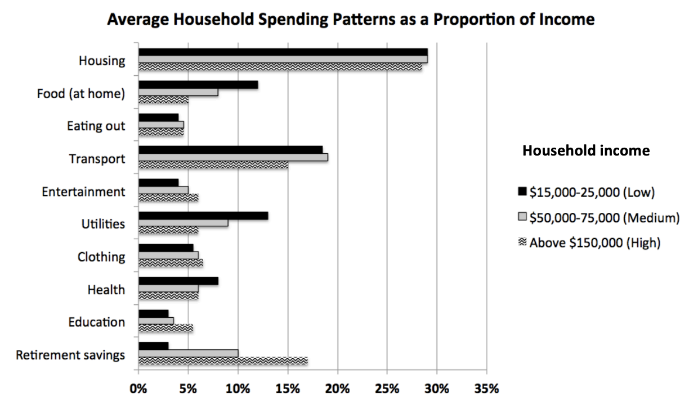

TASK 2
You should spend about 40 minutes on this task. Write at least 250 words
After you finish, use the checklist to evaluate your writing task. Then, compare your task with the sample answer.

Write about the following topic: Many major cities are facing a housing crisis as they cannot provide enough land for new buildings. Some local governments believe the problem could be solved by reassigning park land for residential development, because this land would be better used for housing.
To what extent do you agree or disagree?
Give reasons for your answer and include any relevant examples from your own knowledge or experience.

